Insertando imagen...

**ACME-SF**

G1.007

**Planning and progress report D02**

27/02/2024

# Cover

|  |  |
| --- | --- |
| **Repository:** <https://github.com/Pablo-Caballero-Maria/Acme-One-24.1.0-C1.07> | |
| **Student #1**  **ID:** 31878881F  **UVUS:**  pabcabmar3  **Name:** Caballero María, Pablo **Roles:** manager, developer | **Student #2**  **ID Number:**49034820Q  **UVUS:** mararnmon  **Name:** Arnáiz Montero, Marco Antonio  **Roles:** developer, operator |
| **Student #3**  **ID Number:** 77865211E  **UVUS:**  alfalolan  **Name:** Alonso Lanzarán, Alfonso Luis  **Roles:** developer, tester | **Student #4**  **ID Number:** 53932912M  **UVUS:** albsanmim  **Name:** Sánchez Mimbrero, Alberto  **Roles:** developer |
| **Student #5**  **ID Number:** 48123111G  **UVUS:** juagarcar4  **Name:** Garcia Carballo, Juan  **Roles:** developer |  |

Table of contents

Cover 2

Executive summary 3

Revision table 3

Introduction 3

Contents 3

Planing chapter 3

Progress chapter 4

Conclusions 4

# Executive summary

A pivotal advancement in this phase has been the creation of the necessary entities that form the backbone of the project’s architecture. Furthermore, these newly created entities were subjected to "informal testing," a process that allowed for an early evaluation of their functionality and interoperability within the project's ecosystem.

Moreover, the team has invested time in analyzing the WIS requirements and diligently completing the required documentation, ensuring that all project activities are well-documented and aligned with the project’s objectives. This initial phase of the project, with its focus on setting up, creating essential entities, and conducting informal testing, has been instrumental in laying a solid foundation for the ACME-SF project.

# Revision table

|  |  |  |
| --- | --- | --- |
| Number | Date | Description |
| 1.0 | 27/02/2024 | Creation of the Document. Create a table of tasks assigned in this sprint, establish a budget, and write the introduction. |
| 1.1 | 08/03/2024 | Write the executive summary and conclusion, include screenshots of the project development, establish the progress record and real cost. |

# Introduction

The Planning and Progress Report D02 for the ACME-SF project, outlines the initial steps and strategic implementations undertaken by a dedicated team of students. This document serves as a blueprint, detailing the tasks assigned, the development of critical project entities, and the initial informal testing phase. Through meticulous planning and a structured approach, the team aims to lay a robust foundation for the project's architecture, ensuring alignment with the project's goals and objectives. The focus on early evaluation of entity functionality and interoperability within the project's ecosystem underscores the commitment to quality and efficiency from the outset. This report captures the essence of the project's initial phase, emphasizing the importance of detailed documentation and rigorous analysis in achieving project milestones and setting a clear path for future development stages.

Contents

## Planning

* + Task assigned this delivery:

|  |  |  |  |  |  |
| --- | --- | --- | --- | --- | --- |
| **Title** | **Assignees** | **Priority** | **Estimate** | **Size** | **Role** |
| Task G-003/I: Create "Risk" entity | MarcoAnarmo | P0 | 20 | M | developer |
| Task G-005/T: Test "Banner" entity | MarcoAnarmo | P0 | 5 | S | developer |
| Task G-011/I: Create "Administrator dashboard" | MarcoAnarmo | P1 | 40 | M | developer |
| Task G-006/T: Test "Risk" entity | MarcoAnarmo | P0 | 20 | M | developer |
| Task G-000/M: Create tasks | Pablo-Caballero-Maria | P0 | 50 | M | manager |
| Task G-001/I: Create "Claim" entity | Pablo-Caballero-Maria | P0 | 20 | M | developer |
| Task G-010/I: Include initial data | Pablo-Caballero-Maria | P1 | 20 | M | developer |
| Task G-006/T: Test "Claim" entity | Pablo-Caballero-Maria | P0 | 20 | M | developer |
| Task G-007/T: Test "Notice" entity | mimbrero | P0 | 20 | M | developer |
| Task G-011/I: Create "Administrator dashboard" | mimbrero | P1 | 40 | M | developer |
| Task G-004/I: Create "Notice" entity | mimbrero | P0 | 20 | M | developer |
| Task G-003/T: Test "Risk" entity | mimbrero | P0 | 5 | S | developer |
| Task G-012/M: Produce an analysis report. | alfalolan | P1 | 20 | M | analyst |
| Task G-008/T: Test "Banner" entity | JuanGarciaCarballo | P0 | 60 | M | developer |
| Task G-005/I: Create "Banner" entity | JuanGarciaCarballo | P0 | 60 | M | developer |
| Task G-019/M: Produce a UML domain model | alfalolan | P1 | 20 | S | developer |
| Task G-020: Create the delivery | MarcoAnarmo | P0 | 15 | S | operator |
| Task G-013/M: Produce a planning and progress report. | JuanGarciaCarballo | P1 | 60 | M | developer |
| Task G-011/T: Test "Administrator dashboard" | mimbrero | P0 | 10 | S | developer |
| Task G-001/T: Test "Claim" entity | alfalolan | P0 | 1 | S | developer |
| Task G-002/I: Create "Objective" entity | alfalolan | P0 | 1 | M | developer |
| Task G-007/T: Test "Objective" entity | alfalolan | P0 | 1 | M | developer |

* + Different moments in the delivery

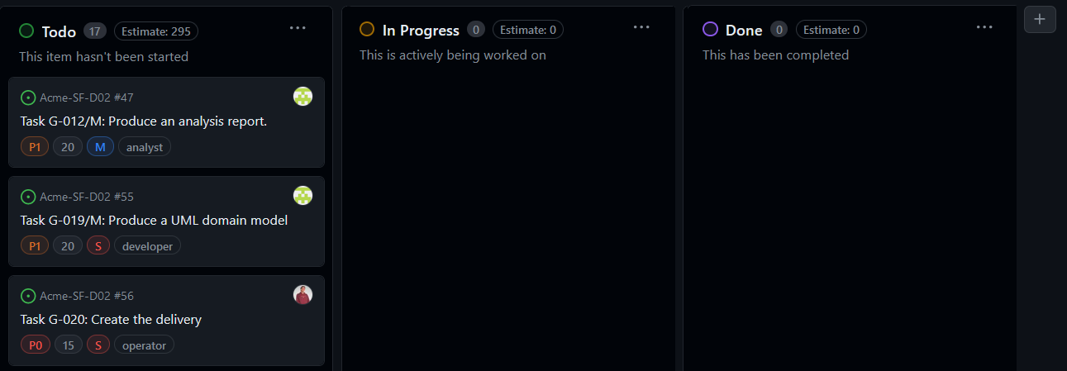

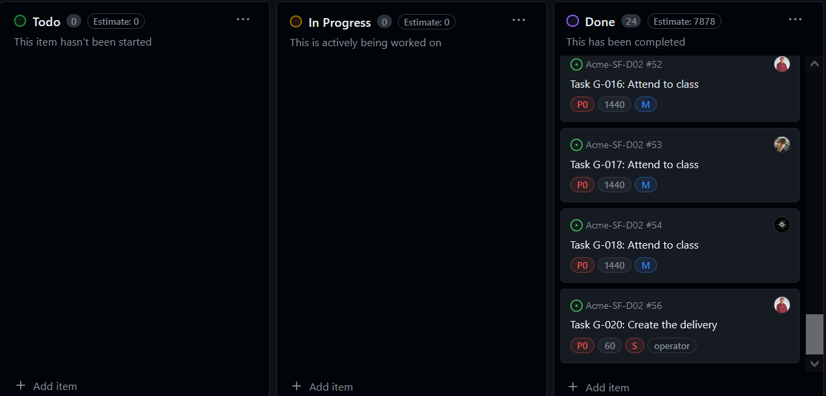

* + Budget

|  |  |  |  |  |
| --- | --- | --- | --- | --- |
| **Title** | **Estimate (min)** | **Role** | **€ per hour** | **budget of the task** |
| Task G-003/I: Create "Risk" entity | 60 | developer | 20 | 20 |
| Task G-005/T: Test "Banner" entity | 60 | developer | 20 | 20 |
| Task G-011/I: Create "Administrator dashboard" | 60 | developer | 20 | 20 |
| Task G-006/T: Test "Risk" entity | 60 | developer | 20 | 20 |
| Task G-000/M: Create tasks | 60 | manager | 20 | 20 |
| Task G-001/I: Create "Claim" entity | 60 | developer | 20 | 20 |
| Task G-010/I: Include initial data | 60 | developer | 20 | 20 |
| Task G-006/T: Test "Claim" entity | 60 | developer | 20 | 20 |
| Task G-007/T: Test "Notice" entity | 60 | developer | 20 | 20 |
| Task G-011/I: Create "Administrator dashboard" | 60 | developer | 20 | 20 |
| Task G-004/I: Create "Notice" entity | 60 | developer | 20 | 20 |
| Task G-003/T: Test "Risk" entity | 60 | developer | 20 | 20 |
| Task G-012/M: Produce an analysis report. | 60 | analyst | 30 | 30 |
| Task G-008/T: Test "Banner" entity | 60 | developer | 20 | 20 |
| Task G-005/I: Create "Banner" entity | 60 | developer | 20 | 20 |
| Task G-019/M: Produce a UML domain model | 60 | developer | 20 | 20 |
| Task G-020: Create the delivery | 60 | operator | 20 | 20 |
| Task G-013/M: Produce a planning and progress report. | 60 | developer | 20 | 20 |
| Task G-011/T: Test "Administrator dashboard" | 60 | developer | 20 | 20 |
| Task G-001/T: Test "Claim" entity | 60 | developer | 20 | 20 |
| Task G-002/I: Create "Objective" entity | 60 | developer | 20 | 20 |
| Task G-007/T: Test "Objective" entity | 60 | developer | 20 | 20 |
|  |  |  | TOTAL | 450 |

Total cost of the equipment: 1000€ + 700€ + 1100€ + 950€ + 650€ = 4400€

Total: 4850€

With a lineal amortization in 3 years of 1.616,67€ per year.

## Progress

* + Progress records

Juan Garcia Carballo, Ratio:1, is the best value possible, because he has completed all the task assigned.

Marco Antonio Arnáiz Montero: I received a 1 which is the best value because I have completed all my tasks in an effective way.

Caballero María, Pablo: The ratio between the completed tasks and the assigned tasks was 1, meaning that all the tasks were completed.

Alfonso Luis Alonso Lanzarán Performance indicator:1, is the best value possible, because I have completed all the task assigned.

Alberto Sánchez Mimbrero: received a 0.9 which is a really good value, but he didn’t complete all his individual task, so a reduction in his ratio has been applied due to not writing his corresponding planning and progress report.

According to the performance indicator specified in the chartering report, this performance is considered “good” for each member, so all of them will be able to choose their roles for the next deliverable.

* + Conflicts

Intentionally blank

* + Real Cost

|  |  |  |  |  |
| --- | --- | --- | --- | --- |
| **Title** | **Real Cost (min)** | **Role** | **€ per hour** | **Real Cost of the task** |
| Task G-003/I: Create "Risk" entity | 60 | developer | 20 | 20 |
| Task G-005/T: Test "Banner" entity | 60 | developer | 20 | 20 |
| Task G-011/I: Create "Administrator dashboard" | 60 | developer | 20 | 20 |
| Task G-006/T: Test "Risk" entity | 60 | developer | 20 | 20 |
| Task G-000/M: Create tasks | 60 | manager | 20 | 20 |
| Task G-001/I: Create "Claim" entity | 60 | developer | 20 | 20 |
| Task G-010/I: Include initial data | 60 | developer | 20 | 20 |
| Task G-006/T: Test "Claim" entity | 60 | developer | 20 | 20 |
| Task G-007/T: Test "Notice" entity | 60 | developer | 20 | 20 |
| Task G-011/I: Create "Administrator dashboard" | 60 | developer | 20 | 20 |
| Task G-004/I: Create "Notice" entity | 60 | developer | 20 | 20 |
| Task G-003/T: Test "Risk" entity | 60 | developer | 20 | 20 |
| Task G-012/M: Produce an analysis report. | 60 | analyst | 30 | 30 |
| Task G-008/T: Test "Banner" entity | 60 | developer | 20 | 20 |
| Task G-005/I: Create "Banner" entity | 60 | developer | 20 | 20 |
| Task G-019/M: Produce a UML domain model | 60 | developer | 20 | 20 |
| Task G-020: Create the delivery | 60 | operator | 20 | 20 |
| Task G-013/M: Produce a planning and progress report. | 60 | developer | 20 | 20 |
| Task G-011/T: Test "Administrator dashboard" | 60 | developer | 20 | 20 |
| Task G-001/T: Test "Claim" entity | 60 | developer | 20 | 20 |
| Task G-002/I: Create "Objective" entity | 60 | developer | 20 | 20 |
| Task G-007/T: Test "Objective" entity | 60 | developer | 20 | 20 |
|  |  |  | TOTAL | 450 |

Total cost of the equipment: 1000€ + 700€ + 1100€ + 950€ + 650€ = 4400€

Total: 4850€

With a lineal amortization in 3 years of 1.616,67€ per year.

# Conclusions

The Planning and Progress Report D02 effectively captures the initial achievements and challenges faced by the ACME-SF project team. With the successful creation and informal testing of essential entities, alongside comprehensive documentation and budgeting efforts, the team has established a strong foundation for subsequent phases of the project.

The meticulous planning and task allocation highlighted in this report reflect a strategic and analytical approach to project management. The team's ability to meet assigned tasks with a performance indicator of "good" for each member showcases their dedication and effectiveness in collaborative efforts. Despite the absence of conflicts and the accurate alignment of real costs with planned budgets, the report underlines the team's commitment to transparency, accountability, and continuous improvement. As the project moves forward, the groundwork laid in this initial phase will be instrumental in navigating future challenges and achieving the project's overarching goals.

Bibliography

Intentionally blank